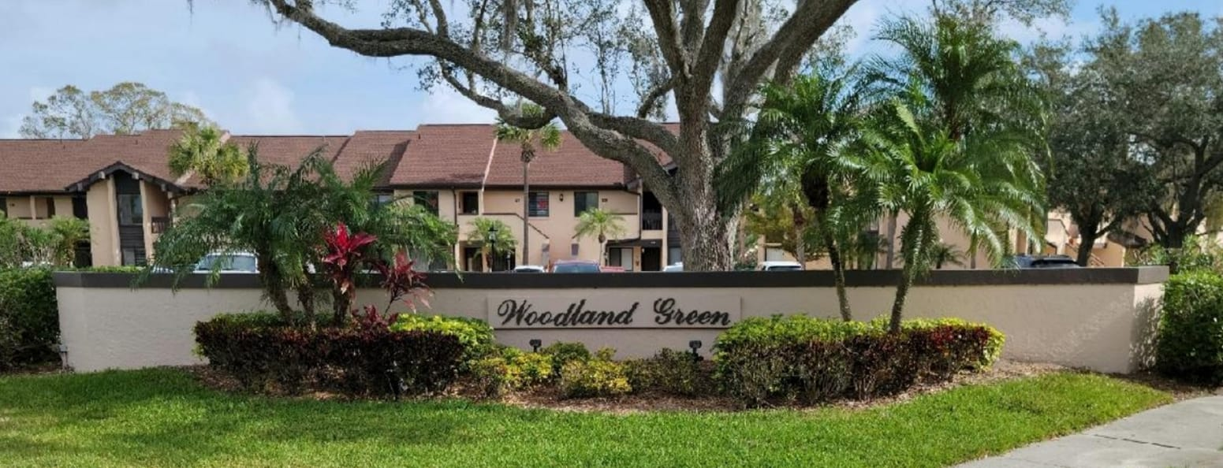

Welcome to your new home and neighborhood!
Wishing you a smooth move-in!
We look forward to getting to know you!

Warm Regards,
The Woodland Green Condominium Association Welcoming Committee
Karen Manella (585) 590-7249, Julia Falvo, Jack and Sue Smith

PACC Rep – Sue Smith

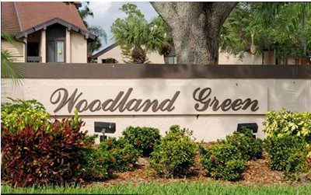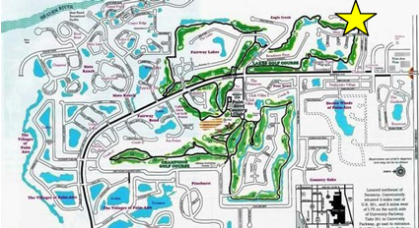

Woodland Green is a 72-unit condominium (36 two-story condos and 36 villas) that nestle on the 5th hole of the Lakes Golf Course of the Palm Aire Country Club. All the lanais look out on the golf course.
It was developed in the mid to late 19802 with one or two of the original owners still living here.
The lap pool and small clubhouse host aerobic classes and card parties, cocktail parties, and suppers throughout the year. And don’t forget bingo!
We are at the end of Timberlake Drive and Misty Oaks Boulevard, so traffic is minimal. The gate to University Park Country Club is only used for emergencies, so that is not an issue. We are a very quiet community.

Board of Directors

Officers Directors
President: Vince Ruma Gene Guerra
Vice President: Ron Pelliccia Stephanie Lund
Treasurer: Gene Northrup Sue Smith
Secretary: Karen Manella

DOCUMENTS

WGCA Rules Regulations – 16 May 2025

